# Durable Furnitures

Baker

## Taper Torchiere

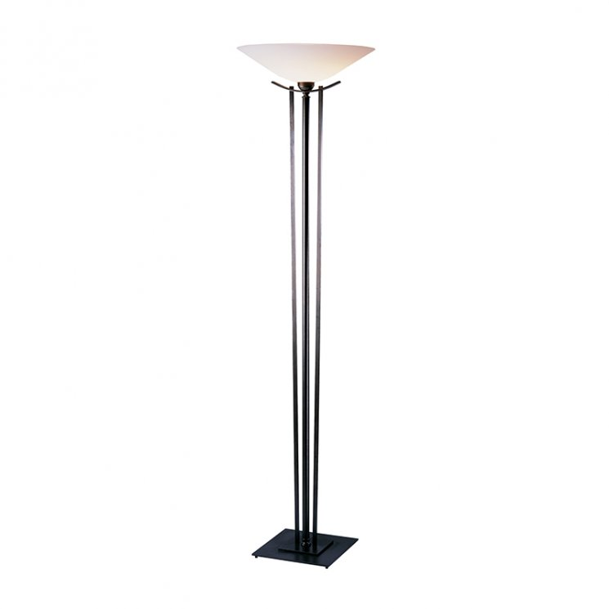

The long three piece column topped with a frosted glass bowl shade found in our Taper Torchiere Lamp speaks to the forms of the tall candle torches from times long gone. Hubbardton Forge artisans have captured the essence of antique design in a contemporary style floor lamp sure to captivate all. The upward radiance emitted from the top of this unique lamp casts a luminescent glow on all of its surroundings.